Course Description

Human Anatomy and Physiology is a rigorous introductory, laboratory-based course that explores the structure and function of the human body. The organization of the body and body systems and biochemical composition will be introduced. An investigation of the impact of disease processes on each system will also be addressed. The laboratory component will include anatomical studies using dissection, as well as microscopy. Strong Biology interest and background is encouraged.

*Pre-Requisites: Student must have passed high school Biology Course and End-of- Course Test.

Course Set-Up

This course will be a two-semester course taught by two instructors. Some students will be addressing Anatomy the first semester, while others complete the physiology component. At the beginning of second-semester, students will switch instructors to complete the remainder of the course.

Anatomy Semester- Mrs. Owen

Physiology Semester- Mrs. Jolley

CONTACT US

Carlie.shanks@bvcps.net

Jessica.jolley@bvcps.net
540- 261-2127

GRADING

Tests will be given occasionally to assess knowledge of course content and will count as 35% of the 9-weeks grade.

Quizzes will be given often and will count as 30% of the 9-weeks grade. Disease and Disorders Diary will count as a quiz grade

Labs and projects are an essential part of the course and will count for 25% of the 9-weeks grade.

Classwork and daily participation credit will count as 10% of the 9-weeks grade.

Midterm and Final exam will count as 10% each (20% total) for the final course grade. These scores will be averaged with the four-nine-week scores (80% total).

ExPectations and procedures

Be on time and prepared for class (bring all materials and homework needed)

Follow all school and teacher rules without exception (no cell phones, backpacks, food, etc.)

Be respectful (to teacher, others, yourselves, and materials)

Give 100% each and every class

When absent, follow hand-book procedures. It is the student’s responsibility to get and make sure make-up work is completed in a timely manner
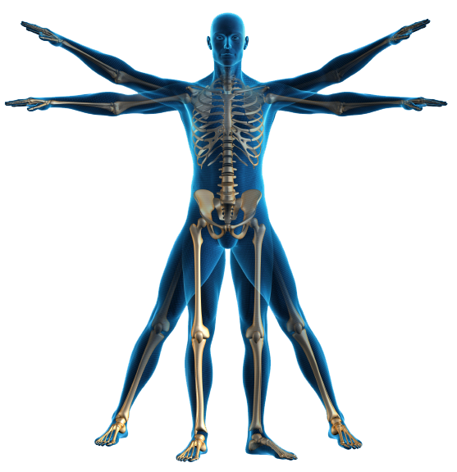

MATerials needed

Paper *

Writing utensil *

Textbook (school issued)

3-Ring Binder

*Items needed every class period without exception and provided by the student

GradING Scale
A 95-100
92-94
B+ 89-91
B 86-88
83-85
C+ 80-82
C 77-79
74-76
D+ 71-73
D 65-70
F 0-64

